APPENDIX A

SOLUTIONS TO PROBLEMS

A.1 (i) $566.

(ii) The two middle numbers are 480 and 530; when these are averaged, we obtain 505, or $505.

(iii) 5.66 and 5.05, respectively.

(iv) The average increases to $586 while the median is unchanged ($505).

A.2 (i) This is just a standard linear equation with intercept equal to 3 and slope equal to .2. The intercept is the number of missed classes for a student who lives on campus.

(ii) 3 + .2(5) = 4 classes.

(iii) 10(.2) = 2 classes.

A.3 If price = 15 and income = 200, quantity = 120 – 9.8(15) + .03(200) = –21, which is nonsense. This shows that linear demand functions generally cannot describe demand over a wide range of prices and income.

A.4 (i) The percentage point change is 5.6 – 6.4 = –.8, or an eight-tenths of a percentage point decrease in the unemployment rate.

(ii) The percentage change in the unemployment rate is 100[(5.6 – 6.4)/6.4] = –12.5%.

A.5 The majority shareholder is referring to the percentage point increase in the stock return, while the CEO is referring to the change relative to the initial return of 15%. To be precise, the shareholder should specifically refer to a 3 percentage point increase.

A.6 (i) 100[42,000 – 35,000)/35,000] = 20%.

(ii) The approximate proportionate change is log(42,000) – log(35,000) .182, so the approximate percentage change is %18.2. [Note: log(⋅) denotes the natural log.]

A.7 (i) When exper = 0, log(salary) = 10.6; therefore, salary = exp(10.6) $40,134.84. When exper = 5, salary = exp[10.6 + .027(5)] $45,935.80.

(ii) The approximate proportionate increase is .027(5) = .135, so the approximate percentage change is 13.5%.

(iii) 100[(45,935.80 – 40,134.84)/40,134.84) 14.5%, so the exact percentage increase is about one percentage point higher.

A.8 From the given equation, Δgrthemp = –.78(Δsalestax). Since both variables are in proportion form, we can multiply the equation through by 100 to turn each variable into percentage form. This leaves the slope as –.78. So, a one percentage point increase in the sales tax rate (say, from 4% to 5%) reduces employment growth by –.78 percentage points.

A.9 (i) The relationship between yield and fertilizer is graphed below.

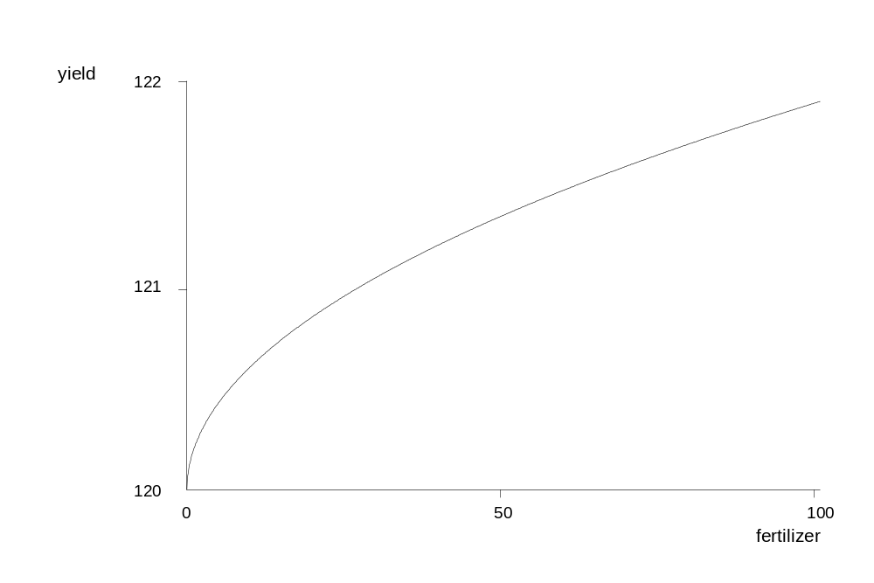

(ii) Compared with a linear function, the function

yield = .120 + .19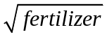

has a diminishing effect, and the slope approaches zero as fertilizer gets large. The initial pound of fertilizer has the largest effect, and each additional pound has an effect smaller than the previous pound.

